18-1: Finding Order in Diversity

Natural selection and other processes have led to a staggering diversity of organisms.
Biologists have identified and named about 1.5 million species so far.
They estimate that 2–100 million additional species have yet to be discovered.

Why Classify?
To study the diversity of life, biologists use a classification system to name organisms and group them in a logical manner.

In the discipline of taxonomy, scientists classify organisms and assign each organism a universally accepted name.
When taxonomists classify organisms, they organize them into groups that have biological significance.

Assigning Scientific Names
Common names of organisms vary, so scientists assign one name for each species.
Because 18th century scientists understood Latin and Greek, they used those languages for scientific names.
This practice is still followed in naming new species.

Early Efforts at Naming Organisms
The first attempts at standard scientific names described the physical characteristics of a species in great detail.
These names were not standardized because different scientists described different characteristics.

Binomial Nomenclature
Carolus Linneaus developed a naming system called binomial nomenclature.
In binomial nomenclature, each species is assigned a two-part scientific name.
The scientific name is italicized.
The first part of the name is the genus to which the organism belongs. A genus is a group of closely related species. The genus name is capitalized.
The second part of the name is unique to each species within the genus. This part of the name often describes an important trait or where the organism lives. The species name is lowercased.

Linnaeus's System of Classification
Linnaeus not only named species, he also grouped them into categories.
Linnaeus's seven levels of classification are—from smallest to largest—
      - species
      - genus
      - family
      - order
      - class
      - phylum
      - kingdom
Each level is called a taxon, or taxonomic category.
Species and genus are the two smallest categories.
Genera that share many characteristics are grouped in a larger category, the family.
An order is a broad category composed of similar families.
The next larger category, the class, is composed of similar orders.
Several different classes make up a phylum.
The kingdom is the largest and most inclusive of Linnaeus's taxonomic categories.

18-3: Kingdoms and Domains
The Tree of Life Evolves
Systems of classification adapt to new discoveries.
Linnaeus classified organisms into two kingdoms—animals and plants.
The only known differences among living things were the fundamental traits that separated animals from plants.

Five Kingdoms
Scientists realized there were enough differences among organisms to make 5 kingdoms:
      - Monera
      - Protista
      - Fungi
      - Plantae
      - Animalia

Six Kingdoms
Recently, biologists recognized that Monera were composed of two distinct groups: Eubacteria and Archaebacteria.
The six-kingdom system of classification includes:
    - Eubacteria
    - Archaebacteria
    - Protista
    - Fungi
    - Plantae
    - Animalia

The Three-Domain System
Molecular analyses have given rise to a new taxonomic category that is now recognized by many scientists.
The domain is a more inclusive category than any other—larger than a kingdom.
The three domains are:
    - Eukarya, which is composed of protists, fungi, plants, and animals.
    - Bacteria, which corresponds to the kingdom Eubacteria.
    - Archaea, which corresponds to the kingdom Archaebacteria.
Modern classification is a rapidly changing science.
As new information is gained about organisms in the domains Bacteria and Archaea, they may be subdivided into additional kingdoms.

Domain Bacteria
Members of the domain Bacteria are unicellular prokaryotes.
Their cells have thick, rigid cell walls that surround a cell membrane.
Their cell walls contain peptidoglycan.
The domain Bacteria corresponds to the kingdom Eubacteria.

Domain Archaea
Members of the domain Archaea are unicellular prokaryotes.
They live in extreme environments.
Their cell walls lack peptidoglycan, and their cell membranes contain unusual lipids not found in any other organism.
The domain Archaea corresponds to the kingdom Archaebacteria.

Domain Eukarya
The domain Eukarya consists of organisms that have a nucleus.
This domain is organized into four kingdoms:
      - Protista
      - Fungi
      - Plantae
      - Animalia

Protista
The kingdom Protista is composed of eukaryotic organisms that cannot be classified as animals, plants, or fungi.
Its members display the greatest variety.
They can be unicellular or multicellular; photosynthetic or heterotrophic; and can share characteristics with plants, fungi, or animals.

Fungi
Members of the kingdom Fungi are heterotrophs.
Most fungi feed on dead or decaying organic matter by secreting digestive enzymes into it and absorbing small food molecules into their bodies.
They can be either multicellular (mushrooms) or unicellular (yeasts).

Plantae
Members of the kingdom Plantae are multicellular, photosynthetic autotrophs.
Plants are nonmotile—they cannot move from place to place.
Plants have cell walls that contain cellulose.
The plant kingdom includes cone-bearing and flowering plants as well as mosses and ferns.

Animalia
Members of the kingdom Animalia are multicellular and heterotrophic.
The cells of animals do not have cell walls.
Most animals can move about.
There is great diversity within the animal kingdom, and many species exist in nearly every part of the planet.

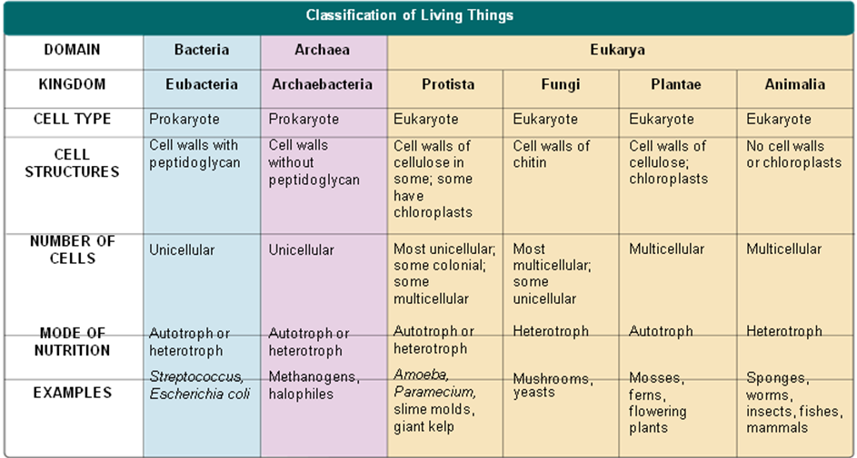

19-2: Viruses

What Is a Virus?
Viruses are particles of nucleic acid, protein, and in some cases, lipids.
Viruses can reproduce only by infecting living cells.
Viruses differ widely in terms of size and structure.
All viruses enter living cells and use the infected cell to produce more viruses.
A typical virus is composed of a core of DNA or RNA surrounded by a protein coat.
A capsid is the virus’s protein coat.
Capsid proteins bind to receptors on the cell surface and “trick” the cell into allowing it inside.
Once inside, viral genes are used to make viral capsid proteins.
The host cell may makes copies of the virus, and be destroyed.
Most viruses are highly specific to the cells they infect.
Viruses that infect bacteria are called bacteriophages.

Viral Infection
Once the virus is inside the host cell, two different processes may occur.
      - Some viruses replicate immediately, killing the host cell.
      - Others replicate, but do not kill the host cell immediately.

Lytic Infection
In a lytic infection, a virus enters a cell, makes copies of itself, and causes the cell to burst.
First, the bacteriophage injects DNA into a bacterium.
The bacteriophage DNA forms a circle.
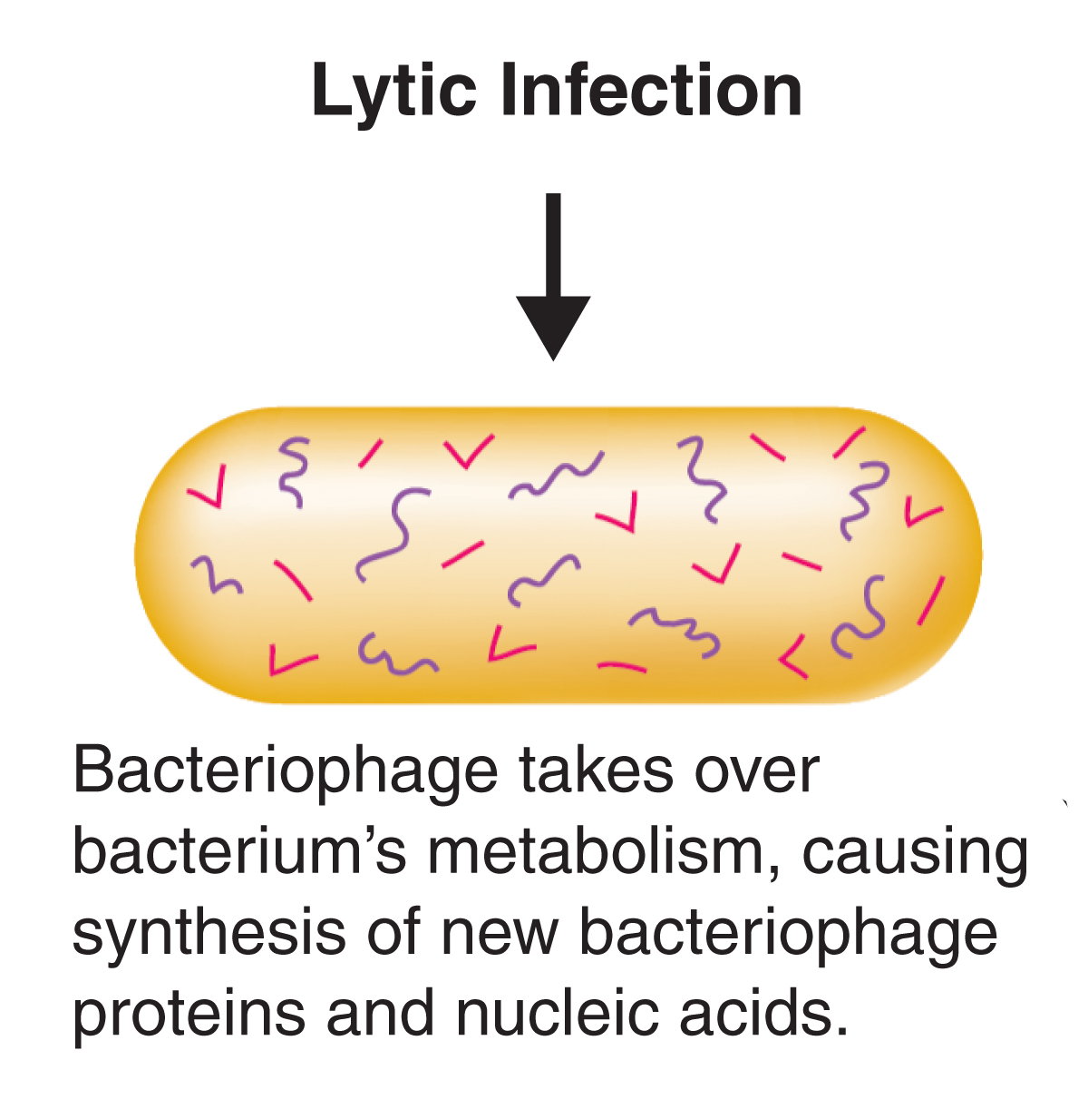

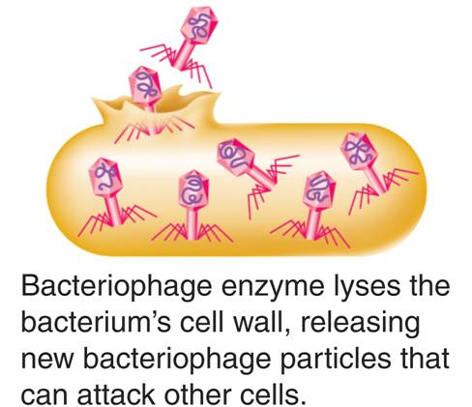

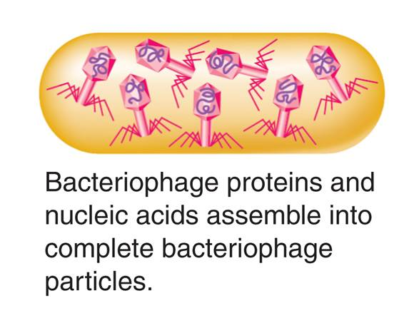

Lysogenic Infection
Other viruses cause lysogenic infections in which a host cell makes copies of the virus indefinitely.
In a lysogenic infection, a virus integrates its DNA into the DNA of the host cell, and the viral genetic information replicates along with the host cell's DNA.
A lysogenic infection begins the same way as a lytic infection.
The bacteriophage injects DNA into a bacterium.
The bacteriophage DNA forms a circle.
The viral DNA embedded in the host's DNA is called a prophage.

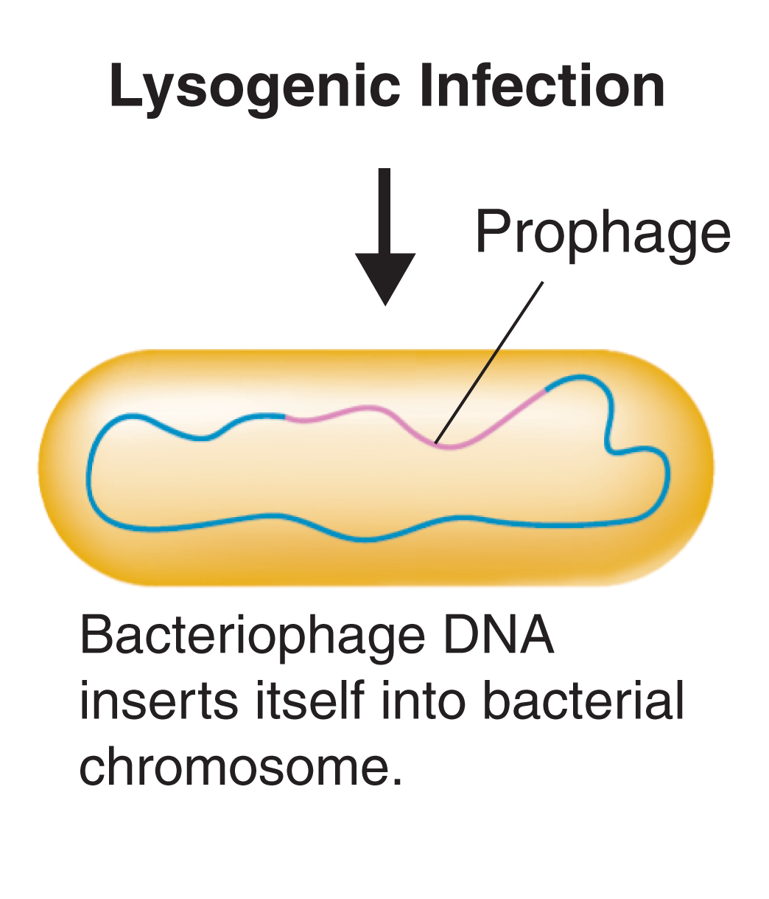
Prophage
Prophage

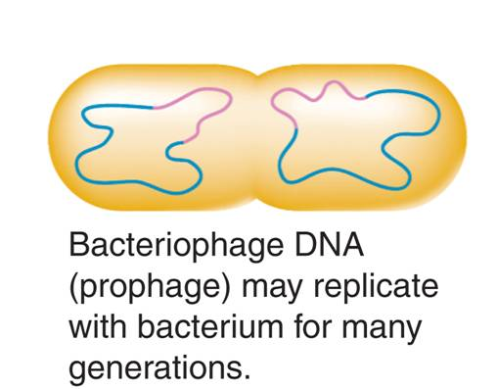
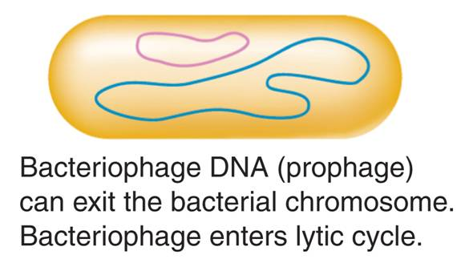
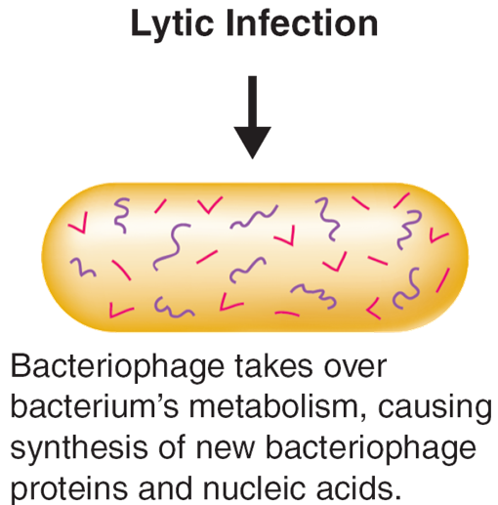

Retroviruses
Retroviruses contain RNA as their genetic information.
When retroviruses infect cells, they make a DNA copy of their RNA.
This DNA is inserted into the DNA of the host cell.
A retrovirus’ genetic information is copied backward—from RNA to DNA.
The virus that causes AIDS is a retrovirus.

Viruses and Living Cells
Viruses must infect a living cell in order to grow and reproduce.
They take advantage of the host’s respiration, nutrition, and all other functions of living things.
Viruses have many of the characteristics of living things.
After infecting living cells, viruses can reproduce, regulate gene expression, and even evolve.
Because viruses are dependent on living things, it seems likely that viruses developed after living cells.
The first viruses may have evolved from genetic material of living cells.
Viruses have continued to evolve over billions of years.

